**CROSS-REGION REPLICATION IN S3**

**Cross-Region Replication (CRR):**

AWS S3 allows you to replicate objects from one S3 bucket to another in a different AWS region. This feature provides benefits such as reduced latency, compliance, security, disaster recovery, and regional efficiency.

Step1: creating 2 buckets in different regions

Step2: Enable the versioning

Step3: cross region replication

**Creating s3 buckets**

• Open AWS console and N.virginia region.

• Go to s3 service.

• Click on create bucket.

• Give name tag as crr111.

• Click on create bucket.

• Create another bucket in seoul region.

• Go to s3 bucket and click on create bucket.

• Give name as crr222.

• Remaining field leave it as default and click on create bucket.

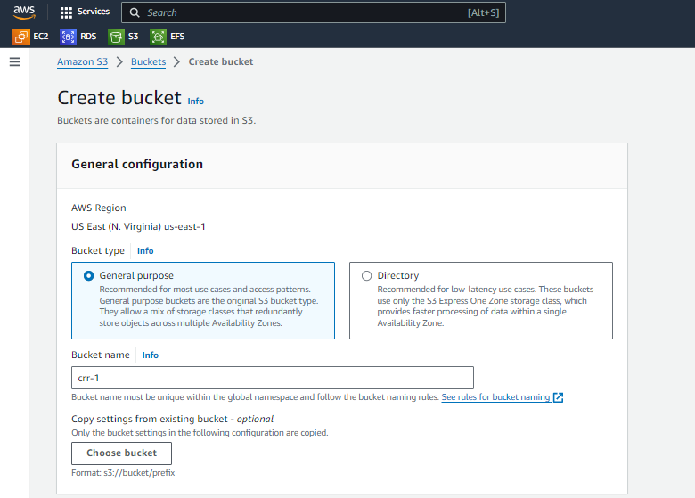

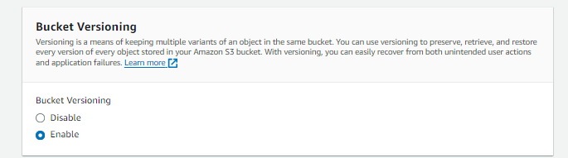

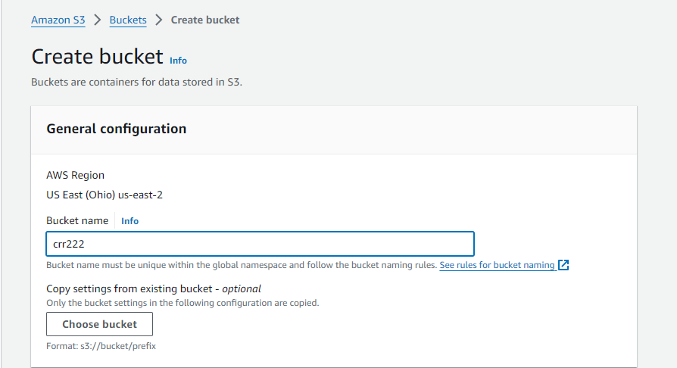

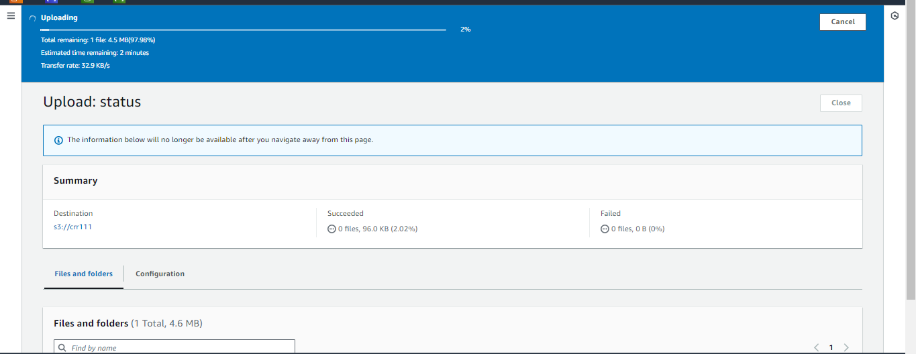

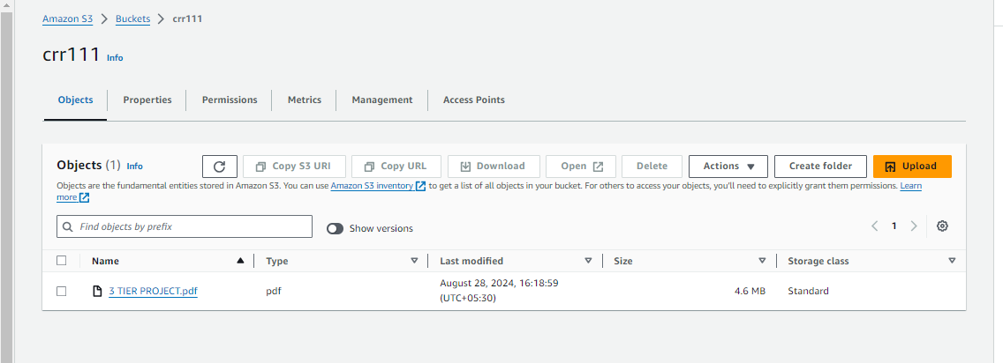

**Cross region replication (CRR):**

• Go to the first bucket which is created in N.virginia region.

• Open crr111 and click on management.

• Go to cross region replication and click on replication rule.

• Give name tag as crr111222.

• Click on apply to all objects in the bucket in source bucket field.

• Select bucket name in destination field.

• Click on replication time control (RTC) in Additional replication options field.

• Remaining fields should be default and click on save.

• The following will showcase the cross-region replication.

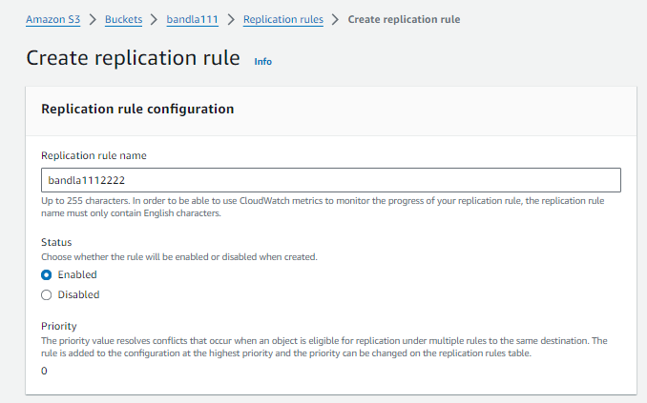

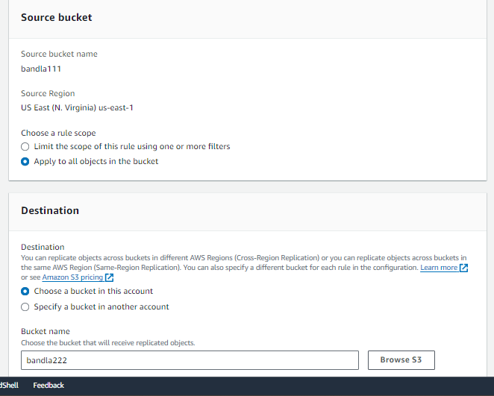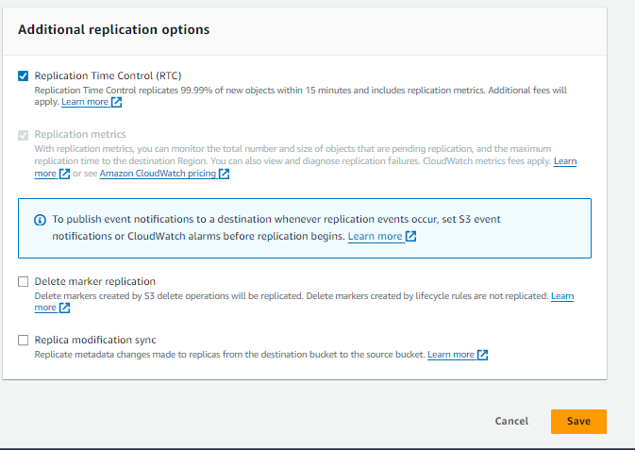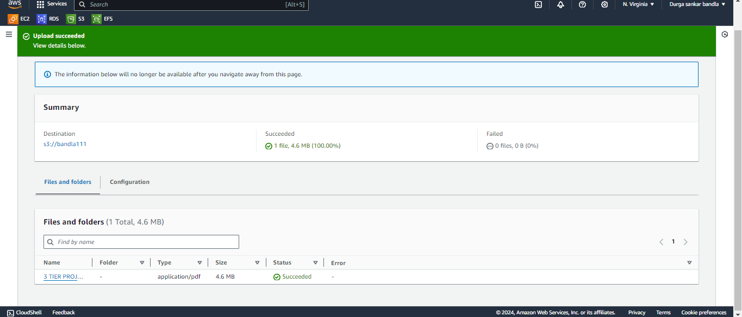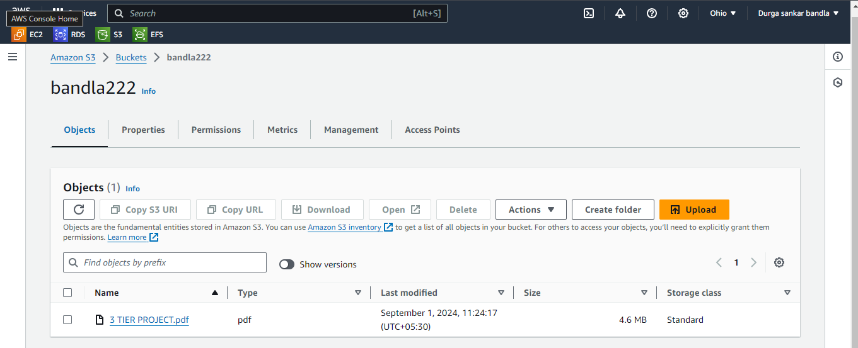

Durgasankar Bandla

[durgasankarbandla99@gmail.com](mailto:durgasankarbandla99@gmail.com)

Batch No : **127**